Professor Julia K Steinberger :
Climate Action and Fight Fascism

Teaching climate crisis thread : 4-7 year-old version.

I did this a few weeks back. It worked rather well? It's a lesson in 4 parts, takes about 1 hour (managed to keep their attention pretty much whole time). ( all the pictures you can find below)

1: Warming Emissions
2: Cumulative warming
3: Impacts
4: Action

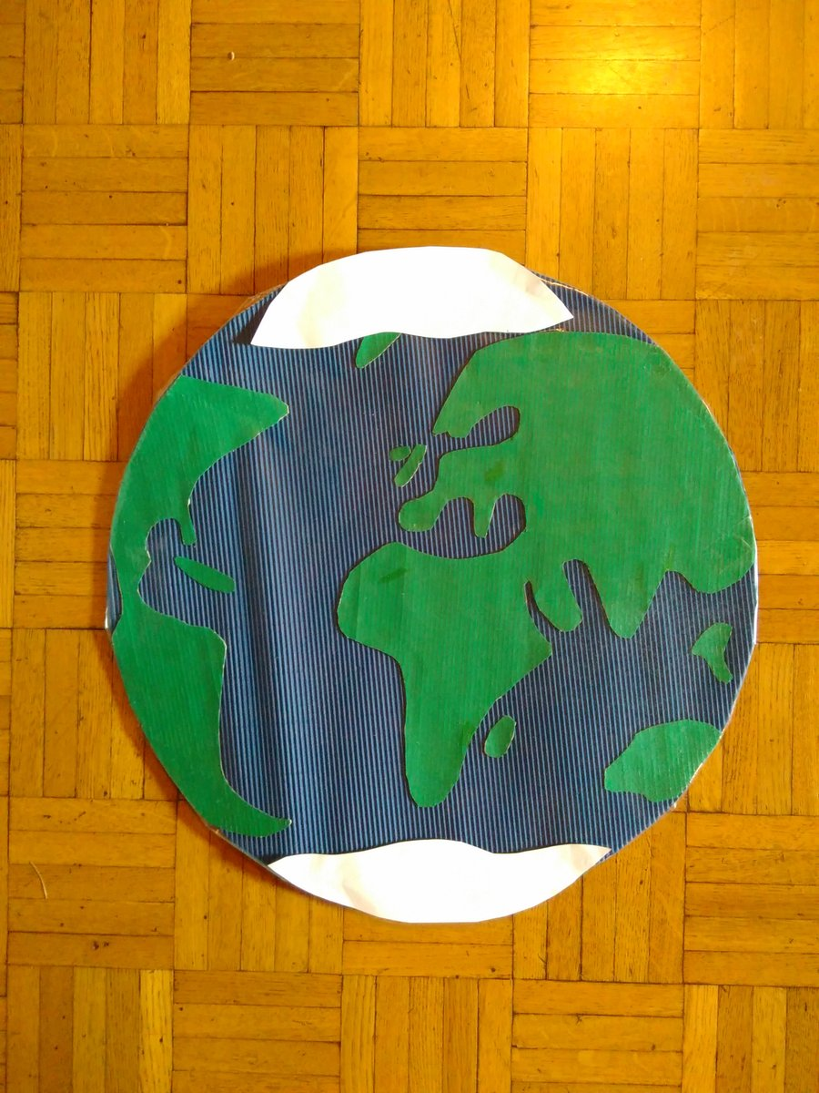

Part 1: warming emissions.

I asked them if they know what global warming or climate change was. They said yes! They always say yes. It's about pollution. What kind? I called it "warming emissions" because that's true & simple. I made a display with the big legos (duplo).

The conversion is straightforward:
1 brick = 1 GtCO2eq, using 47 GtCO2eq
(2014 last year
I could allocate to end-use rather than source, via https://ourworldindata.org/co2-and-other-greenhouse-gas-emissions … ).
20 red: electricity & heat
9 yellow: transport
8 green: industry
6 brown: agriculture
5 blue: residential

Note: allocation far from perfect since electricity used in industry & everywhere else]. I showed the kids the lego stacks & stickers of sources, and asked them to guess which was which? Then I stacked them up (shown next to real scale child!).

They were impressed by the stacking! Good! Then the stack fell down! Even more impressive! Kids pleased with parental lack of lego skills.

part 2: cumulative impacts.

Props: old beat up globe and a scarf. I tell them the warming emissions are like an invisible blanket. Every year we emit the warming gases is like adding another layer of blanket.
The planet is getting to warm, like they would be if their parents kept adding and adding blankets on them, and they couldn't shake them off. They. Get. It.
Cumulative warming = explained to 4-7 yos.
My life mission is accomplished.

part 3: impacts.

This is what took longest. I made a big old flat planet, with removable polar ice caps! And lots of possible impacts. This lesson is brought to you by removable double-sided sticky tape. That stuff is the bomb.
8/
Then I asked them what warming the planet would do. They mentioned extinctions. I should have had more of those stickers. I ended up putting a sticker with panda bears & rhinos up at the North Pole because they all mentioned polar bears. Whoops.
9/

We placed the impacts all over the planet (also removed ice caps). Note fire over UK, storms in Mozambique. This is the part that caused me to break down in tears at 2am when I was trying it out the night before. Not a part of the goddamn planet untouched. Fuck. Poor kids.

n that cheerful note, we move on to

part 4: action.

First we figured out what needs to change in production & consumption systems. I made a good & bad column on board, and, you guessed it, stuck pictures on each side. Lots of discussion & excitement. Mostly fun, this part.

And then we got to the civics part. I explained we needed to make these changes before they grow up, before they can vote. So they have the right to demand these big changes of their grown-ups: teachers, parents, politicians, all of us. I said they could write letters.

The letters were from the older kids (6-7 yos). They were sort of into it. I'm not quite sure what to do with the letters now. Need to think that part through better. Anyway, there you go. It worked. It took some preparation & can be improved but it worked.

Also planetary impacts (part 3) need some more explanation. Clockwise from top left: - drought - storm - heavy rains - glacier receding (especially important for Swiss children - but also for South Asia obviously) - flood (see or land) 14/

Clockwise from bottom middle:
- Extinct land-based species (need more of these )
- Extinct sea-based species (coral reefs in this case)
- Deforestation or forest being harmed by climate Center: fires. During discussion, they came up with most of them on their own.

Easily the hardest part to teach. Especially when they made comments like "We flew to the Maldives on holiday and I went snorkeling and my daddy said at least I could see the fish before they disappeared." WTAF, "daddy", WTAF. Where do we go from there?
because I'm a tired dodo-head and forgot to write it up front at the top that everyone is welcome to use as much of this as they want, and give ideas for changes as well. That's the whole point of sharing it! And with that, good night!

